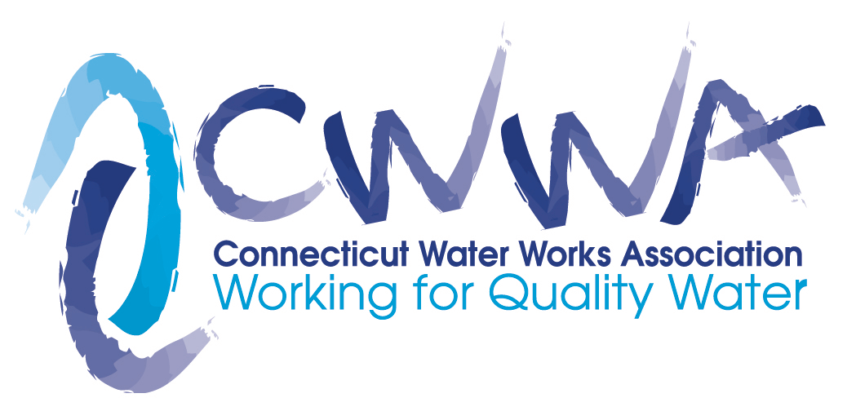
NOTICE
December 1, 2019
2020 - 2021 Nominations for Directors and Officers
The Connecticut Water Works Association, Inc. (CWWA)

Pursuant to CWWA’s Bylaws and Constitution, Article VIII, if you are interested in being considered to serve as a director or officer of CWWA’s Board or in nominating an individual for consideration to serve as a director or officer of the Board, please contact the Nominating Chair, John Herlihy, Past President, CWWA, at jherlihy@aquarionwater.com by December 31, 2019.
Service on CWWA’s Board is very rewarding. It allows you to play a key role in shaping public policies affecting the state’s water industry. It also allows you to interact with your peers on a regular basis and exchange ideas and information. The board generally meets on the third or fourth Friday of the month.
To be eligible to serve on the Board, an individual must be an employee of a utility member of CWWA in good standing. Also, it is important that our Board reflect the composition of the membership based on the form of ownership: investor-owned, municipal-owned and regional water authorities, as well as a balance of representation from small, medium and large water companies.
Terms of Office: The President, Past President, Vice President, Secretary and Treasurer serve a term of one year or until a successor is chosen. Directors serve a term of three years. The Board includes one director-at-large position which serves a term of one year. The terms commence at the May board meeting.

Nominations will be considered by the Nominating Committee prior to January 15, 2020. The Nominating Committee will then present the slate of nominations to the Board for consideration and ratification at its February Board meeting or special meeting. A copy of the slate will be mailed to the authorized representative of each Utility Member on or before March 5.
Please consider serving on CWWA’s Board or in nominating someone that you believe will contribute to the continued success of CWWA as an organization.
Thank you.
John Herlihy
CWWA – Past President

